**Supplementary Material S1.1**

**Sample numbers for proteomic analysis and physiological measurements**

**Sample numbers for measurements requiring invasive sampling**, i.e proteomics, symbiont cell counts, host protein quantification and estimation of symbiont cell density, and chl *a* measurements

|  |  |  |  |
| --- | --- | --- | --- |
| **pH** | **Symbiotic state** | **Time point** | ***n*** |
| pH 7.68 | Aposymbiotic | 1 | **5** |
| pH 7.68 | Aposymbiotic | 2 | **7** |
| pH 7.68 | Aposymbiotic | 3 | **7** |
| pH 7.68 | Symbiotic | 1 | **5** |
| pH 7.68 | Symbiotic | 2 | **5** |
| pH 7.68 | Symbiotic | 3 | **7** |
| pH 7.95 | Aposymbiotic | 1 | **6** |
| pH 7.95 | Aposymbiotic | 2 | **6** |
| pH 7.95 | Aposymbiotic | 3 | **7** |
| pH 7.95 | Symbiotic | 1 | **6** |
| pH 7.95 | Symbiotic | 2 | **6** |
| pH 7.95 | Symbiotic | 3 | **5** |

**Sample numbers for** Aiptasia pedal disc size measurements (*n* decreased over time from ~100 to ~40 as samples were taken).

|  |  |  |  |
| --- | --- | --- | --- |
| **pH** | **Day** | **Symbiotic state** | ***n*** |
| pH 7.68 | 0 | Sym | 86 |
| pH 7.68 | 7 | Sym | 62 |
| pH 7.68 | 14 | Sym | 61 |
| pH 7.68 | 21 | Sym | 44 |
| pH 7.68 | 26 | Sym | 41 |
| pH 7.95 | 0 | Sym | 85 |
| pH 7.95 | 7 | Sym | 62 |
| pH 7.95 | 14 | Sym | 60 |
| pH 7.95 | 21 | Sym | 43 |
| pH 7.95 | 26 | Sym | 39 |
| pH 7.68 | 0 | Apo | 94 |
| pH 7.68 | 7 | Apo | 73 |
| pH 7.68 | 14 | Apo | 72 |
| pH 7.68 | 21 | Apo | 39 |
| pH 7.68 | 26 | Apo | 30 |
| pH 7.95 | 0 | Apo | 107 |
| pH 7.95 | 7 | Apo | 80 |
| pH 7.95 | 14 | Apo | 80 |
| pH 7.95 | 21 | Apo | 48 |
| pH 7.95 | 26 | Apo | 33 |

**Linear models and statistical tests for physiological measurements**

**Fitted linear model for changes in estimated cell densities of *Breviolum minutum per* µg of host protein by pH**

**Linear model formula**: Cell density = 49800– 1056 (pH 7.68)

No effect of header tank was detected.

|  |  |  |  |  |  |
| --- | --- | --- | --- | --- | --- |
| **Coefficients** | **Estimate** | **Std. Error** | **t value** | ***p*-value** | **Significance** |
| (Intercept) | 49800 | 5071 | 9.82 | 9.96e-11 | *** |
| pH 7.68 | 1056 | 7059 | -0.15 | 0.882 |  |
| Header tank effect | NA | NA | NA | NA | NA |

Significance. codes: 0 ‘***’ 0.001 ‘**’ 0.01 ‘*’ 0.05 ‘.’ 0.1 ‘ ’ 1

Residual standard error: 19640 on 29 degrees of freedom

Multiple R-squared: 0.0007704

Adjusted R-squared: -0.03369

F-statistic: 0.02236 on 1 and 29 df

*p*-value: 0.882

**Model ANOVA**

|  |  |  |  |  |  |
| --- | --- | --- | --- | --- | --- |
| **Variation** | **df** | **Sum of squares** | **Mean square** | **F-value** | ***p*-value** |
| pH | 1 | 8.63e+06 | 8626363 | 0.022 | 0.882 |
| Residuals | 29 | 1.12e+10 | 3.86e+08 |  |  |

**Shapiro-Wilk normality test**

|  |  |  |
| --- | --- | --- |
| **Data** | **W** | ***p*-value** |
| Cell densities | 0.93556 | 0.06225 |

**Model plots**

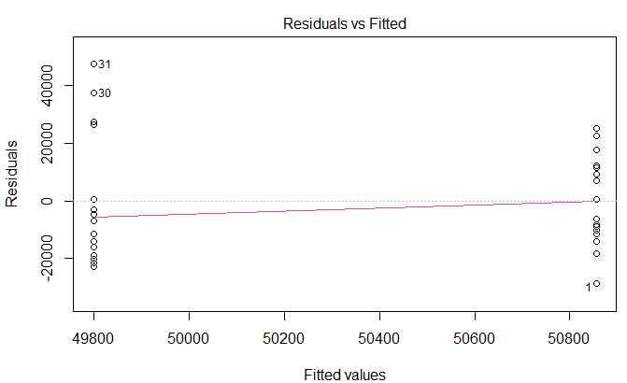

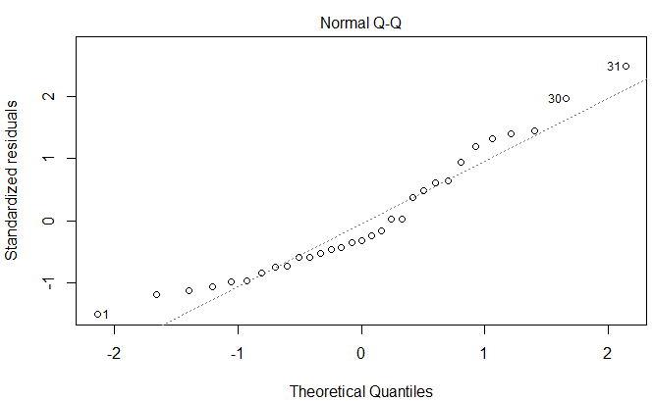

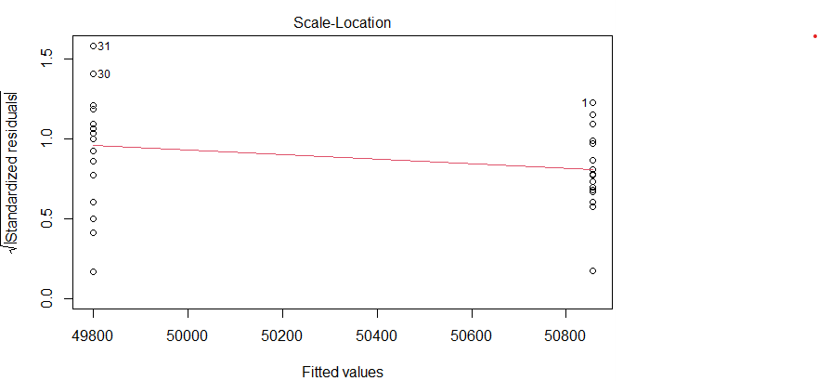

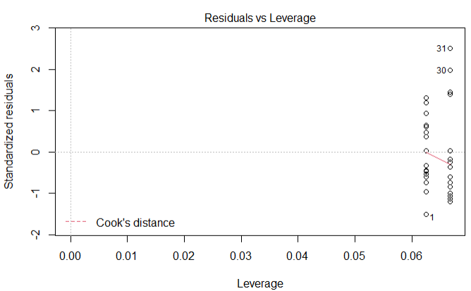

**Fitted linear model for changes in estimated cell densities of *Breviolum minutum per* µg of host protein content over time**

**Linear model formula**: Cell density = 34745 + 7928 (time)

No effect of header tank was detected.

|  |  |  |  |  |  |
| --- | --- | --- | --- | --- | --- |
| **Coefficients** | **Estimate** | **Std. Error** | **t value** | ***p*-value** | **Significance** |
| (Intercept) | 34745 | 8596 | 4.042 | 0.000357 | *** |
| Time point | 7928 | 4031 | 1.967 | 0.058842 | **.** |
| Header tank effect | NA | NA | NA | NA | NA |

Significance. codes: 0 ‘***’ 0.001 ‘**’ 0.01 ‘*’ 0.05 ‘.’ 0.1 ‘ ’ 1

Residual standard error: 18460 on 29 degrees of freedom

Multiple R-squared: 0.1177

Adjusted R-squared: 0.08726

F-statistic: 3.868 on 1 and 29 df

*p*-value: 0.05884

**Model ANOVA**

|  |  |  |  |  |  |
| --- | --- | --- | --- | --- | --- |
| **Variation** | **df** | **Sum of squares** | **Mean square** | **F-value** | ***p*-value** |
| Time point | 1 | 1.318e+09 | 1.318e+09 | 3.868 | 0.0588 |
| Residuals | 29 | 9.879e+09 | 3.407e+08 |  |  |

**Shapiro-Wilk normality test**

|  |  |  |
| --- | --- | --- |
| **Data** | **W** | ***p*-value** |
| Cell densities | 0.93556 | 0.06225 |

**Tukey’s HSD test comparing cell densities at timepoints 1, 2 and 3**

|  |  |  |  |  |  |
| --- | --- | --- | --- | --- | --- |
| **Comparison** | **Difference** | **Lower** | **Upper** | ***p*-value** | **Significance** |
| T2 – T1 | -1634.02 | -21274.1 | 18006.1 | 0.976927 |  |
| T3 – T1 | 16153.78 | -3486.33 | 35793.9 | 0.122425 |  |
| T3 – T2 | 17787.8 | -2314.5 | 37890.1 | 0.090551 |  |

**Model plots**

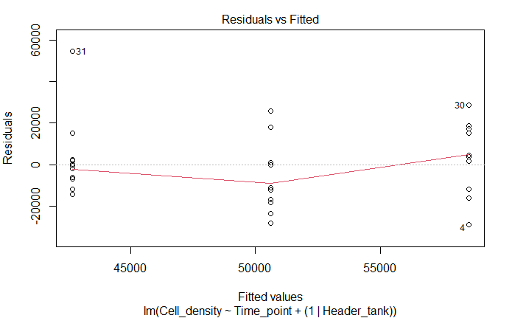

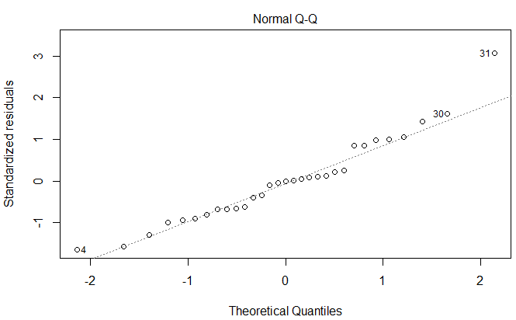

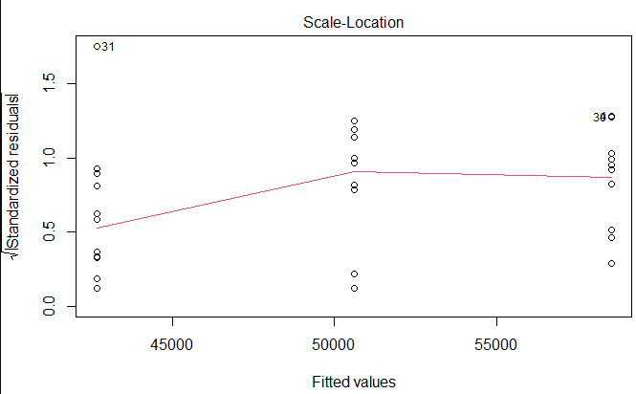

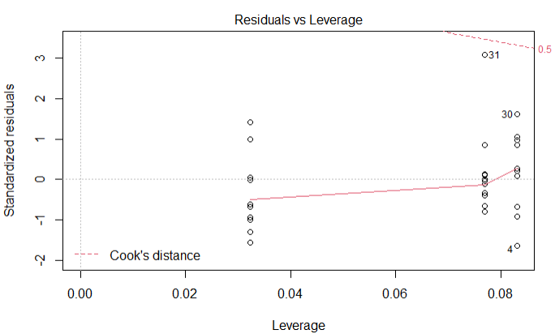

**Fitted linear model for host protein content (µg) by pH**

**Symbiotic anemones**

**Linear model formula**: Protein content = 79.85 + 11.65 (pH 7.68)

No effect of header tank was detected.

|  |  |  |  |  |  |
| --- | --- | --- | --- | --- | --- |
| **Coefficients** | **Estimate** | **Std. Error** | **t value** | ***p*-value** | **Significance** |
| (Intercept) | 79.847 | 6.062 | 13.171 | 1.81e-14 | *** |
| pH 7.68 | 11.653 | 8.573 | 1.359 | 0.184 |  |
| Header tank effect | NA | NA | NA | NA | NA |

Significance. Codes: 0 ‘***’ 0.001 ‘**’ 0.01 ‘*’ 0.05 ‘.’ 0.1 ‘ ’ 1

Residual standard error: 25 on 32 degrees of freedom

Multiple R-squared: 0.05458

Adjusted R-squared: 0.02504

F-statistic: 1.847 on 1 and 32 df

*p*-value: 0.1836

**Model ANOVA**

|  |  |  |  |  |  |
| --- | --- | --- | --- | --- | --- |
| **Variation** | **df** | **Sum of squares** | **Mean square** | **F-value** | ***p*-value** |
| pH | 1 | 1154 | 1154.2 | 1.847 | 0.184 |
| Residuals | 32 | 19993 | 624.8 |  |  |

**Shapiro-Wilk normality test**

|  |  |  |
| --- | --- | --- |
| **Data** | **W** | ***p*-value** |
| Protein content | 0.92631 | 0.02446 |

**Model plots**

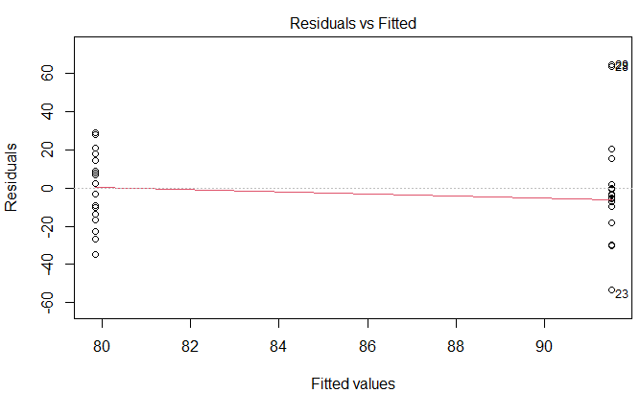

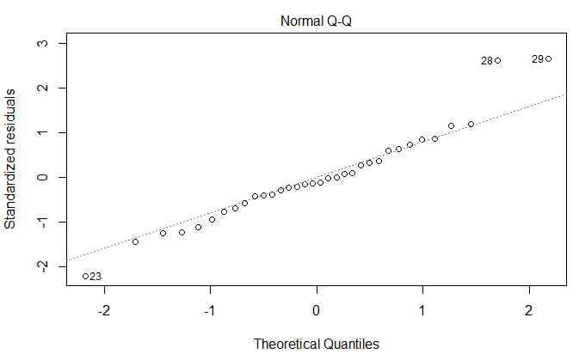

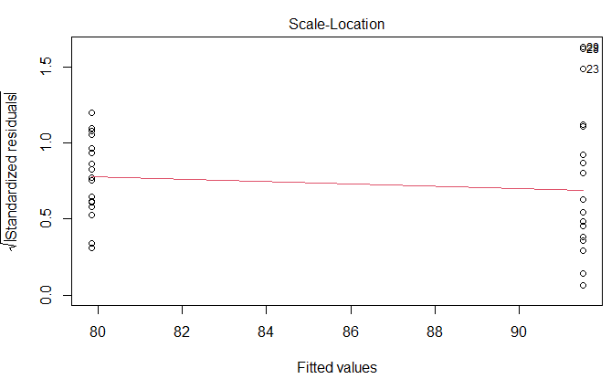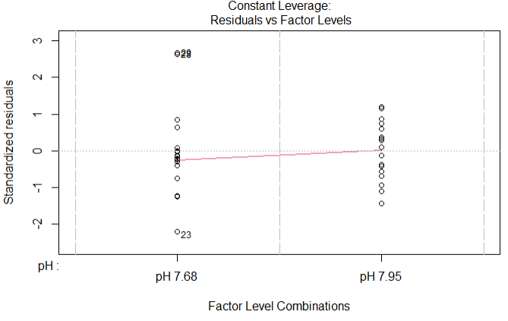

**Fitted linear model for host protein content (µg) over time**

**Symbiotic anemones**

**Linear model formula**: Protein content = 72.97 + 6.26 (time)

No effect of header tank was detected.

|  |  |  |  |  |  |
| --- | --- | --- | --- | --- | --- |
| **Coefficients** | **Estimate** | **Std. Error** | **t value** | ***p*-value** | **Significance** |
| (Intercept) | 72.967 | 11.491 | 6.35 | 3.96e-07 | *** |
| Time point | 6.261 | 5.248 | 1.193 | 0.242 |  |
| Header tank effect | NA | NA | NA | NA | NA |

Significance. Codes: 0 ‘***’ 0.001 ‘**’ 0.01 ‘*’ 0.05 ‘.’ 0.1 ‘ ’ 1

Residual standard error: 25.15 on 32 degrees of freedom

Multiple R-squared: 0.04258

Adjusted R-squared: 0.01267

F-statistic: 1.423 on 1 and 32 df

*p*-value: 0.2416

**Model ANOVA**

|  |  |  |  |  |  |
| --- | --- | --- | --- | --- | --- |
| **Variation** | **df** | **Sum of squares** | **Mean square** | **F-value** | ***p*-value** |
| Time point | 1 | 901 | 900.5 | 1.423 | 0.242 |
| Residuals | 32 | 20247 | 632.7 |  |  |

**Shapiro-Wilk normality test**

|  |  |  |
| --- | --- | --- |
| **Data** | **W** | ***p*-value** |
| Protein content | 0.92631 | 0.02446 |

**Model plots**

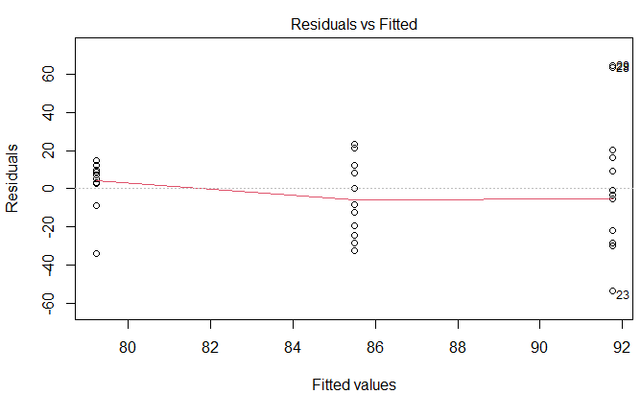

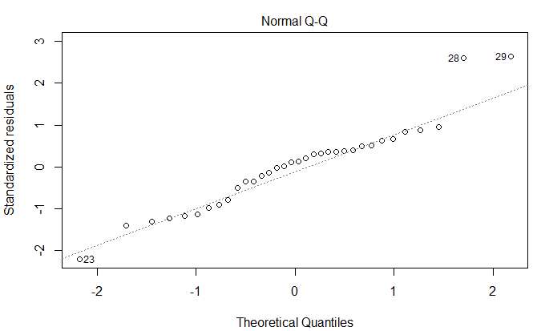 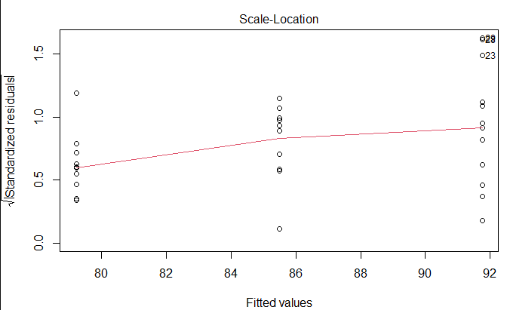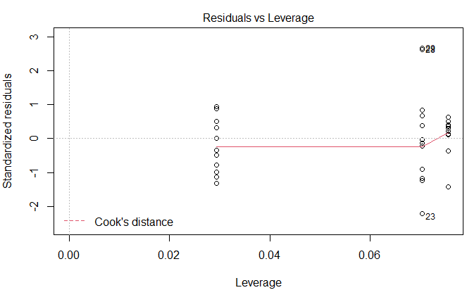

**Fitted linear model for host protein content (µg) by pH**

**Aposymbiotic anemones**

**Linear model formula**: Protein content = 54.07 + 0.68 (pH 7.68)

No effect of header tank was detected.

|  |  |  |  |  |  |
| --- | --- | --- | --- | --- | --- |
| **Coefficients** | **Estimate** | **Std. Error** | **t value** | ***p*-value** | **Significance** |
| (Intercept) | 54.0737 | 3.8983 | 13.871 | 5.16e-16 | *** |
| pH 7.68 | 0.6842 | 5.513 | 0.124 | 0.902 |  |
| Header tank effect | NA | NA | NA | NA | NA |

Significance. Codes: 0 ‘***’ 0.001 ‘**’ 0.01 ‘*’ 0.05 ‘.’ 0.1 ‘ ’ 1

Residual standard error: 16.99 on 36 degrees of freedom

Multiple R-squared: 0.0004277

Adjusted R-squared: -0.02734

F-statistic: 0.0154 on 1 and 36 df

*p*-value: 0.9019

**Model ANOVA**

|  |  |  |  |  |  |
| --- | --- | --- | --- | --- | --- |
| **Variation** | **df** | **Sum of squares** | **Mean square** | **F-value** | ***p*-value** |
| pH | 1 | 4 | 4.45 | 0.015 | 0.902 |
| Residuals | 36 | 10394 | 288.74 |  |  |

**Shapiro-Wilk normality test**

|  |  |  |
| --- | --- | --- |
| **Data** | **W** | ***p*-value** |
| Protein content | 0.94737 | 0.07297 |

**Model plots**

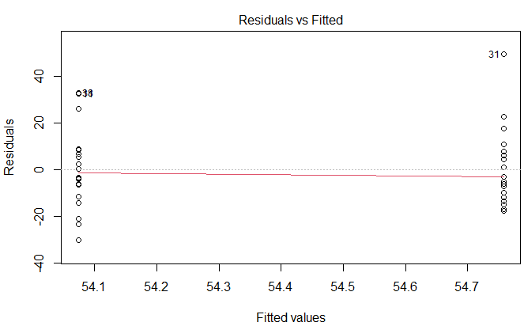

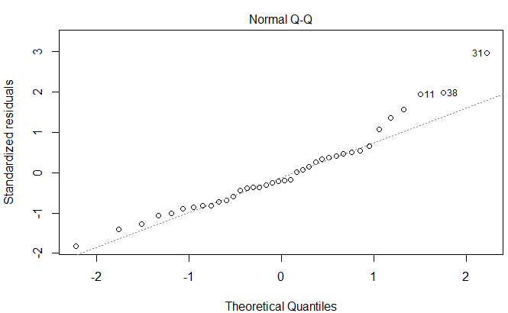

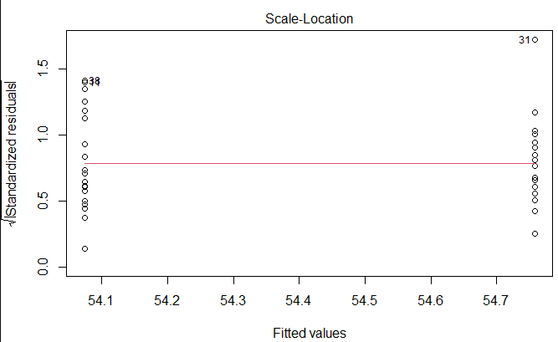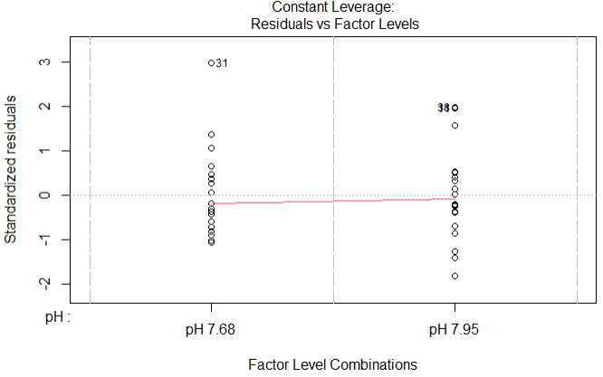

**Fitted linear model for host protein content (µg) over time**

**Aposymbiotic anemones**

**Linear model formula**: Protein content = 44.33 + 4.85 (time)

No effect of header tank was detected.

|  |  |  |  |  |  |
| --- | --- | --- | --- | --- | --- |
| **Coefficients** | **Estimate** | **Std. Error** | **t value** | ***p*-value** | **Significance** |
| (Intercept) | 44.329 | 7.4 | 5.99 | 7.16e-07 | *** |
| Time point | 4.852 | 3.318 | 1.462 | 0.152 |  |
| Header tank effect | NA | NA | NA | NA | NA |

Significance. Codes: 0 ‘***’ 0.001 ‘**’ 0.01 ‘*’ 0.05 ‘.’ 0.1 ‘ ’ 1

Residual standard error: 16.51 on 36 degrees of freedom

Multiple R-squared: 0.05606

Adjusted R-squared: 0.02984

F-statistic: 2.138 on 1 and 36 df

*p*-value: 0.1524

**Model ANOVA**

|  |  |  |  |  |  |
| --- | --- | --- | --- | --- | --- |
| **Variation** | **df** | **Sum of squares** | **Mean square** | **F-value** | ***p*-value** |
| Time point | 1 | 583 | 583 | 2.138 | 0.152 |
| Residuals | 36 | 9816 | 272.7 |  |  |

**Shapiro-Wilk normality test**

|  |  |  |
| --- | --- | --- |
| **Data** | **W** | ***p*-value** |
| Protein content | 0.94737 | 0.07297 |

**Model plots**

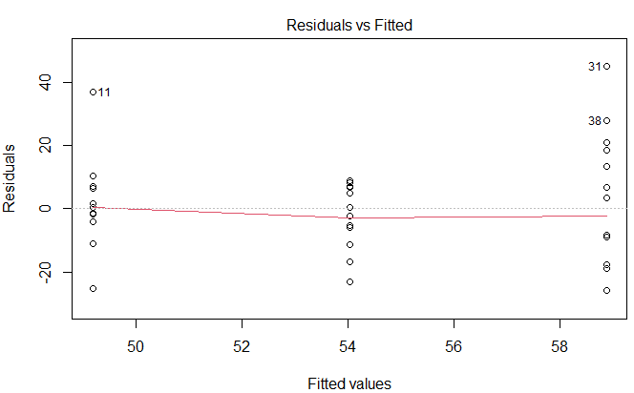

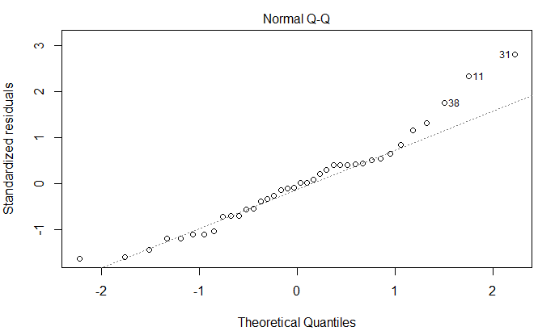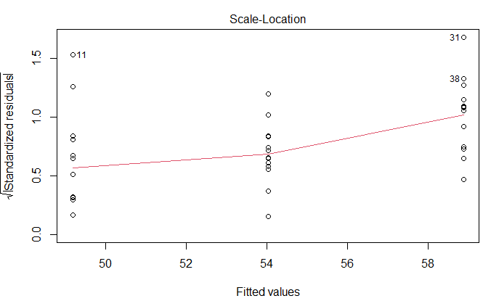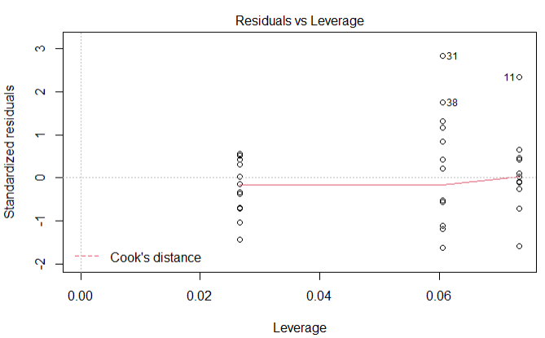

**Fitted linear models for pedal disc diameter (mm) by pH and over time**

**Symbiotic anemones**

**Linear model formula**: Pedal disc diameter = 5.60 + 0.48 (pH 7.68) + 1.40 (time)

No effect of header tank was detected.

|  |  |  |  |  |  |
| --- | --- | --- | --- | --- | --- |
| **Coefficients** | **Estimate** | **Std. Error** | **t value** | ***p*-value** | **Significance** |
| (Intercept) | 5.600535 | 0.106032 | 52.819 | 2.00e-16 | *** |
| pH 7.68 | 0.478587 | 0.114577 | 4.177 | 3.41e-05 | *** |
| Day | 0.04934 | 0.006158 | 8.013 | 6.19e-15 | *** |
| Header tank effect | NA | NA | NA | NA | NA |

Significance. Codes: 0 ‘***’ 0.001 ‘**’ 0.01 ‘*’ 0.05 ‘.’ 0.1 ‘ ’ 1

Residual standard error: 1.383 on 580 degrees of freedom

Multiple R-squared: 0.1239

Adjusted R-squared: 0.1209

F-statistic: 41.02 on 2 and 580 df

*p*-value: 2.20e-16

**Model ANOVA**

|  |  |  |  |  |  |
| --- | --- | --- | --- | --- | --- |
| **Variation** | **df** | **Sum of squares** | **Mean square** | **F-value** | ***p*-value** |
| pH 7.95 | 1 | 34.1 | 34.13 | 17.88 | 2.73e-05 |
| Day | 1 | 123.5 | 123.55 | 64.62 | 5.12 e-15 |
| Residuals | 580 | 1108.9 | 1.91 |  |  |

**Shapiro-Wilk normality test**

|  |  |  |
| --- | --- | --- |
| **Data** | **W** | ***p*-value** |
| Pedal disc diameter | 0.94228 | 0.02861 |

**Tukey’s HSD test comparing pedal disc diameter** **at Days 0, 7, 14, 21 and 26**

|  |  |  |  |  |  |
| --- | --- | --- | --- | --- | --- |
| **Comparison** | **Difference** | **Lower** | **Upper** | ***p*-value** | **Significance** |
| Day 7 – Day 0 | 0.4319 | -0.01402 | 0.877817 | 0.062898 | . |
| Day 14 – Day 0 | 0.88178 | 0.432669 | 1.33089 | 1.1e-06 | *** |
| Day 21 – Day 0 | 0.84699 | 0.349133 | 1.344847 | 3.94e-05 | *** |
| Day 26 – Day 0 | **1.400044** | 0.887954 | 1.912134 | 0 | *** |
| Day 14 – Day 7 | 0.44988 | -0.03321 | 0.932974 | 0.081672 | . |
| Day 21 – Day 7 | 0.415091 | -0.11363 | 0.943808 | 0.201237 |  |
| Day 26 – Day 7 | 0.968145 | 0.426004 | 1.510285 | 1.31e-05 | *** |
| Day 21 – Day 14 | -0.03479 | -0.5662 | 0.496623 | 0.999769 |  |
| Day 26 – Day 14 | 0.518265 | -0.0265 | 1.063034 | 0.071062 | . |
| Day 26 – Day 21 | 0.553054 | -0.03255 | 1.138661 | 0.074587 | . |

**Model plots**

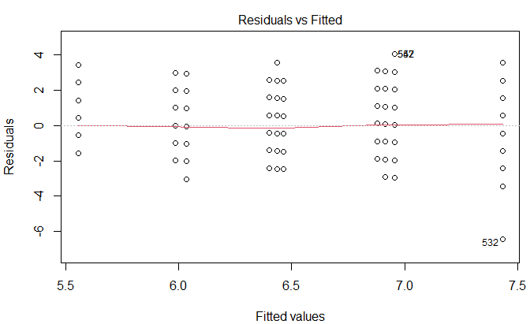

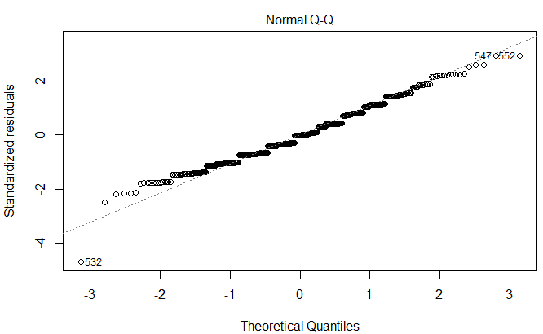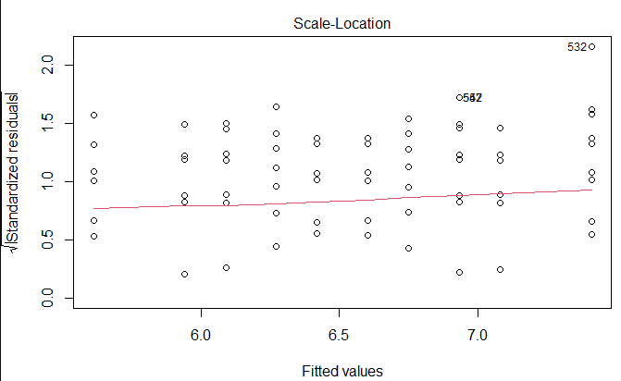

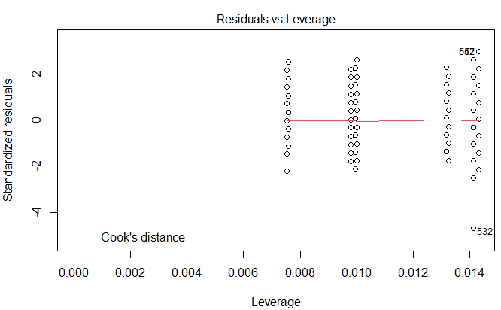

**Linear model formula (including interaction term)**:

Pedal disc diameter = 5.63 + 0.42 (pH 7.69) + 0.05 (time) – 0.01 (pH 7.95 * Day)

No effect of header tank was detected.

|  |  |  |  |  |  |
| --- | --- | --- | --- | --- | --- |
| **Coefficients** | **Estimate** | **Std. Error** | **t value** | ***p*-value** | **Significance** |
| (Intercept) | 5.631099 | 0.126541 | 44.50 | 2.00e-16 | *** |
| pH 7.68 | 0.417973 | 0.178452 | 2.342 | 0.0195 | * |
| Day | 0.052036 | 0.008657 | 6.011 | 3.26e-09 | *** |
| pH:Day | 0.00546 | 0.012325 | 0.443 | 0.6577 |  |
| Header tank effect | NA | NA | NA | NA | NA |

Significance. Codes: 0 ‘***’ 0.001 ‘**’ 0.01 ‘*’ 0.05 ‘.’ 0.1 ‘ ’ 1

Residual standard error: 1.384 on 579 degrees of freedom

Multiple R-squared: 0.1242

Adjusted R-squared: 0.1197

F-statistic: 27.38 on 3 and 579 df

*p*-value: 2.00e-16

**Model ANOVA**

|  |  |  |  |  |  |
| --- | --- | --- | --- | --- | --- |
| **Variation** | **df** | **Sum of squares** | **Mean square** | **F-value** | ***p*-value** |
| pH | 1 | 34.1 | 34.13 | 17.814 | 2.83e-05 |
| Day | 1 | 122.8 | 122.84 | 64.116 | 6.46e-15 |
| pH:Day | 1 | 0.4 | 0.38 | 0.196 | 0.658 |
| Residuals | 579 | 1109.3 | 1.92 |  |  |

**Shapiro-Wilk normality test**

|  |  |  |
| --- | --- | --- |
| **Data** | **W** | ***p*-value** |
| Pedal disc diameter | 0.94228 | 0.02861 |

**Model plots**

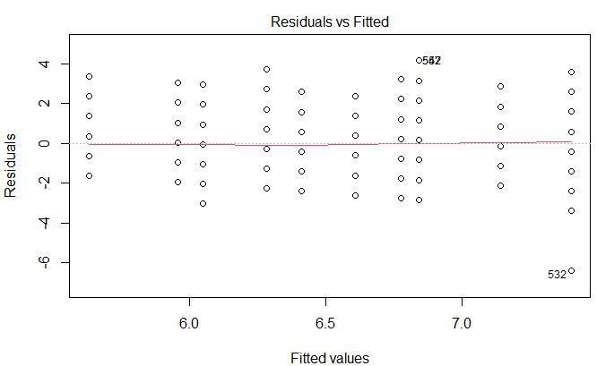

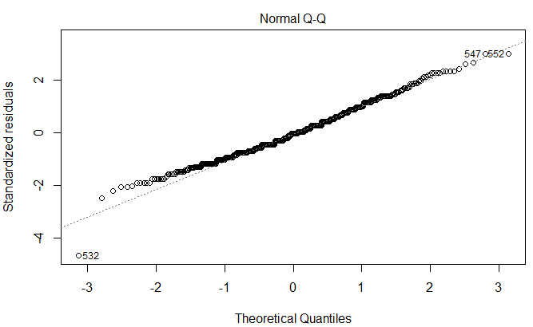

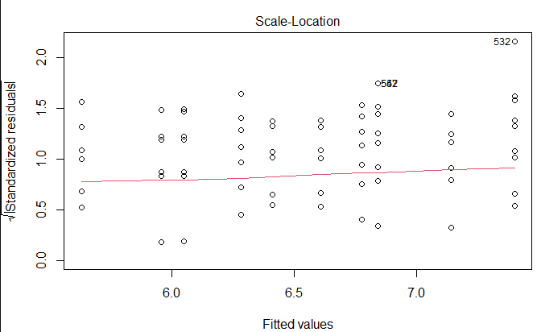

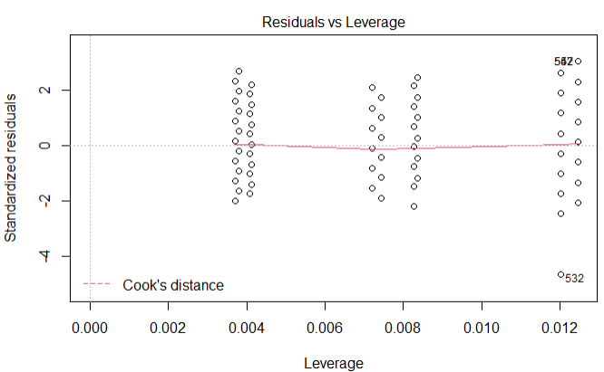

**Fitted linear model for pedal disc diameter (mm) by pH**

**Aposymbiotic anemones**

**Linear model formula**: Pedal disc diameter = 3.26 – 0.05 (pH 7.68)

No effect of header tank was detected.

|  |  |  |  |  |  |
| --- | --- | --- | --- | --- | --- |
| **Coefficients** | **Estimate** | **Std. Error** | **t value** | ***p*-value** | **Significance** |
| (Intercept) | 3.25862 | 0.05389 | 60.473 | 2e-16 | *** |
| pH 7.68 | -0.05408 | 0.07864 | -0.688 | 0.492 |  |
| Header tank effect | NA | NA | NA | NA | NA |

Significance. Codes: 0 ‘***’ 0.001 ‘**’ 0.01 ‘*’ 0.05 ‘.’ 0.1 ‘ ’ 1

Residual standard error: 1.005 on 654 degrees of freedom

Multiple R-squared: 0.0007225

Adjusted R-squared: -0.0008055

F-statistic: 0.4728 on 1 and 654 df

*p*-value: 0.4919

**Model ANOVA**

|  |  |  |  |  |  |
| --- | --- | --- | --- | --- | --- |
| **Variation** | **df** | **Sum of squares** | **Mean square** | **F-value** | ***p*-value** |
| pH 7.95 | 1 | 0.5 | 0.4778 | 0.473 | 0.492 |
| Residuals | 654 | 660.8 | 1.0105 |  |  |

**Shapiro-Wilk normality test**

|  |  |  |
| --- | --- | --- |
| **Data** | **W** | ***p*-value** |
| Pedal disc diameter | 0.89761 | 0.221 |

**Model plots**

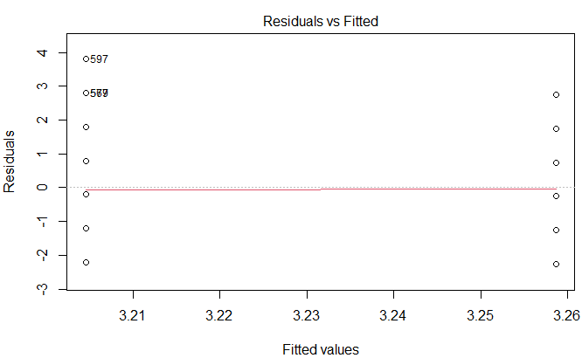

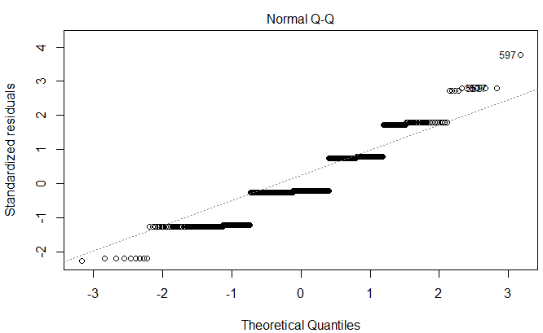

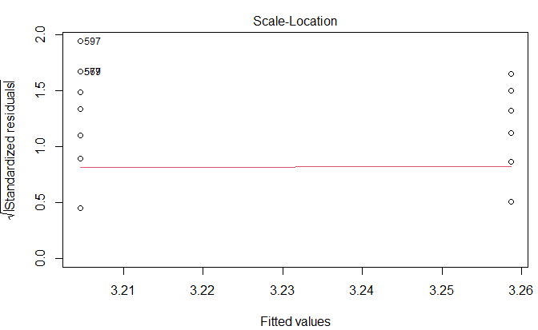

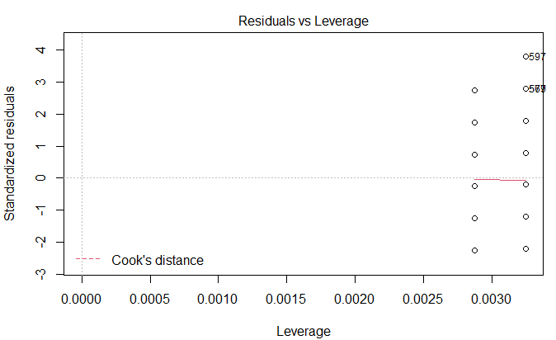

**Fitted linear model for pedal disc diameter (mm) over time**

**Aposymbiotic anemones**

**Linear model formula**: Pedal disc diameter = 2.69 + 1.60 (time)

No effect of header tank was detected.

|  |  |  |  |  |  |
| --- | --- | --- | --- | --- | --- |
| **Coefficients** | **Estimate** | **Std. Error** | **t value** | ***p*-value** | **Significance** |
| (Intercept) | 2.695487 | 0.053231 | 50.64 | 2e-16 | *** |
| Day | 0.052935 | 0.003965 | 13.35 | 2e-16 | *** |
| Header tank effect | NA | NA | NA | NA | NA |

Significance. Codes: 0 ‘***’ 0.001 ‘**’ 0.01 ‘*’ 0.05 ‘.’ 0.1 ‘ ’ 1

Residual standard error: 0.8914 on 654 degrees of freedom

Multiple R-squared: 0.2142

Adjusted R-squared: 0.213

F-statistic: 178.3 1 on 1 and 654 df

*p*-value: 2.20e-16

**Model ANOVA**

|  |  |  |  |  |  |
| --- | --- | --- | --- | --- | --- |
| **Variation** | **df** | **Sum of squares** | **Mean square** | **F-value** | ***p*-value** |
| Day | 1 | 141.6 | 141.64 | 178.3 | 2e-16 |
| Residuals | 654 | 519.7 | 0.79 |  |  |

**Shapiro-Wilk normality test**

|  |  |  |
| --- | --- | --- |
| **Data** | **W** | ***p*-value** |
| Pedal disc diameter | 0.89761 | 0.221 |

**Tukey’s HSD test comparing pedal disc diameter** **at Days 0, 7, 14, 21 and 26**

|  |  |  |  |  |  |
| --- | --- | --- | --- | --- | --- |
| **Comparison** | **Difference** | **Lower** | **Upper** | ***p*-value** | **Significance** |
| Day 7 – Day 0 | 0.04341 | -0.2136 | 0.300424 | 0.990624 |  |
| Day 14 – Day 0 | 0.595182 | 0.337689 | 0.852675 | 0 | *** |
| Day 21 – Day 0 | 0.794819 | 0.487396 | 1.102242 | 0 | *** |
| Day 26 – Day 0 | **1.602701** | 1.256816 | 1.948586 | 0 | *** |
| Day 14 – Day 7 | 0.551772 | 0.277437 | 0.826106 | 5e-07 | *** |
| Day 21 – Day 7 | 0.751409 | 0.429748 | 1.073069 | 0 | *** |
| Day 26 – Day 7 | 1.55929 | 1.200692 | 1.917889 | 0 | *** |
| Day 21 – Day 14 | 0.199637 | -0.12241 | 0.521681 | 0.43728 |  |
| Day 26 – Day 14 | 1.007519 | 0.648576 | 1.366461 | 0 | *** |
| Day 26 – Day 21 | 0.807882 | 0.411592 | 1.204172 | 4e-07 | *** |

**Model plots**

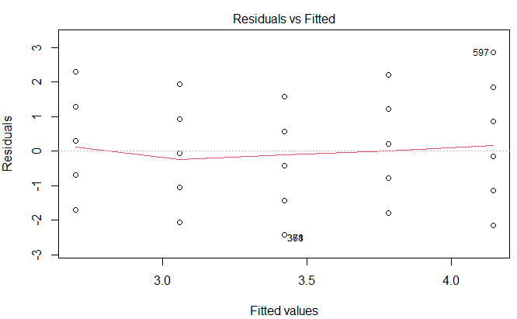

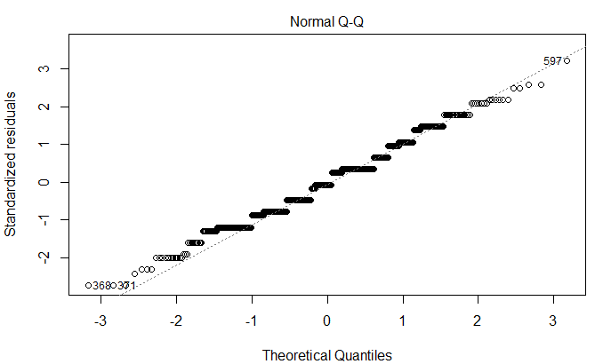

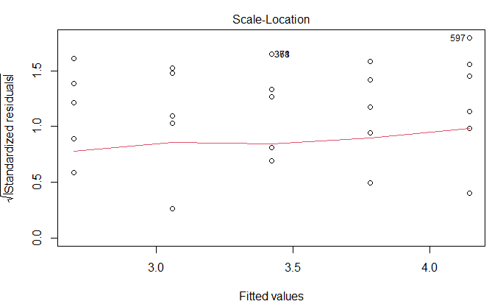

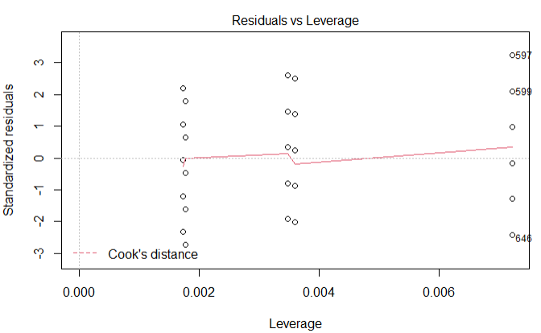

**Fitted linear model for ΦPSII by pH**

**Linear model formula**: ΦPSII = 0.54 + 0.02 (pH 7.68)

No effect of header tank was detected.

|  |  |  |  |  |  |
| --- | --- | --- | --- | --- | --- |
| **Coefficients** | **Estimate** | **Std. Error** | **t value** | ***p*-value** | **Significance** |
| (Intercept) | 0.53993 | 0.01075 | 50.245 | 2e-16 | *** |
| pH 7.68 | 0.02156 | 0.0152 | 1.418 | 0.162 |  |
| Header tank effect | NA | NA | NA | NA | NA |

Significance. Codes: 0 ‘***’ 0.001 ‘**’ 0.01 ‘*’ 0.05 ‘.’ 0.1 ‘ ’ 1

Residual standard error: 0.05584 on 52 degrees of freedom

Multiple R-squared: 0.03725

Adjusted R-squared: 0.01874

F-statistic: 2.012 on 1 and 52 df

*p*-value: 0.162

**Model ANOVA**

|  |  |  |  |  |  |
| --- | --- | --- | --- | --- | --- |
| **Variation** | **df** | **Sum of squares** | **Mean square** | **F-value** | ***p*-value** |
| pH | 1 | 0.00627 | 0.006273 | 2.012 | 0.162 |
| Residuals | 52 | 0.16212 | 0.003118 |  |  |

**Shapiro-Wilk normality test**

|  |  |  |
| --- | --- | --- |
| **Data** | **W** | ***p*-value** |
| ΦPSII | 0.98068 | 0.53 |

**Model plots**

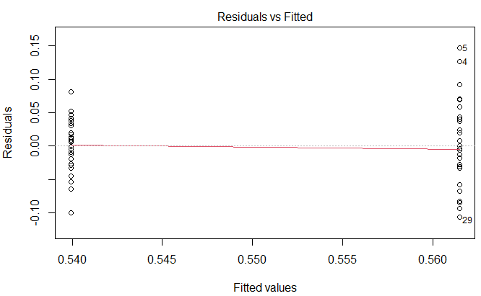

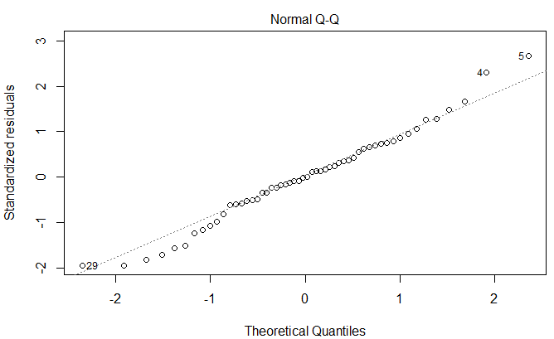

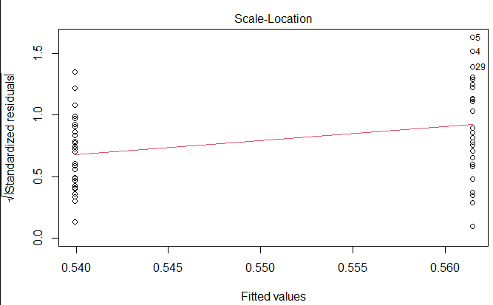

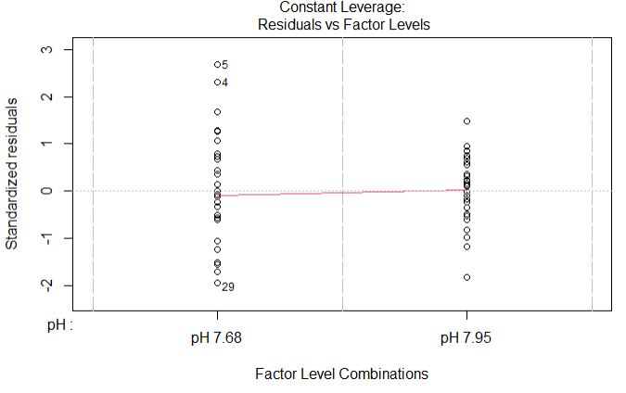

**Fitted linear model for ΦPSII over time**

**Linear model formula**: ΦPSII = 0.58 + 0.02 (time)

No effect of header tank was detected.

|  |  |  |  |  |  |
| --- | --- | --- | --- | --- | --- |
| **Coefficients** | **Estimate** | **Std. Error** | **t value** | ***p*-value** | **Significance** |
| (Intercept) | 0.578519 | 0.019132 | 30.238 | 2e-16 | *** |
| Week | -0.01088 | 0.006877 | -1.583 | 0.12 |  |
| Header tank effect | NA | NA | NA | NA | NA |

Significance. Codes: 0 ‘***’ 0.001 ‘**’ 0.01 ‘*’ 0.05 ‘.’ 0.1 ‘ ’ 1

Residual standard error: 0.05558 on 52 degrees of freedom

Multiple R-squared: 0.04596

Adjusted R-squared: 0.02762

F-statistic: 2.505 on 1 and 52 df

*p*-value: 0.1195

**Model ANOVA**

|  |  |  |  |  |  |
| --- | --- | --- | --- | --- | --- |
| **Variation** | **df** | **Sum of squares** | **Mean square** | **F-value** | ***p*-value** |
| Week | 1 | 0.00774 | 0.00774 | 2.505 | 0.12 |
| Residuals | 52 | 0.16066 | 0.00309 |  |  |

**Shapiro-Wilk normality test**

|  |  |  |
| --- | --- | --- |
| **Data** | **W** | ***p*-value** |
| ΦPSII | 0.98068 | 0.53 |

**Model plots**

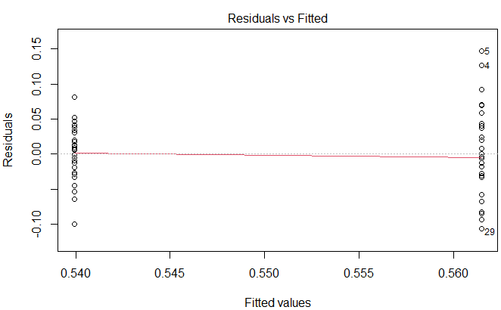

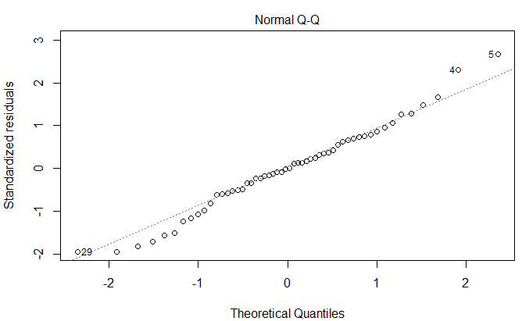

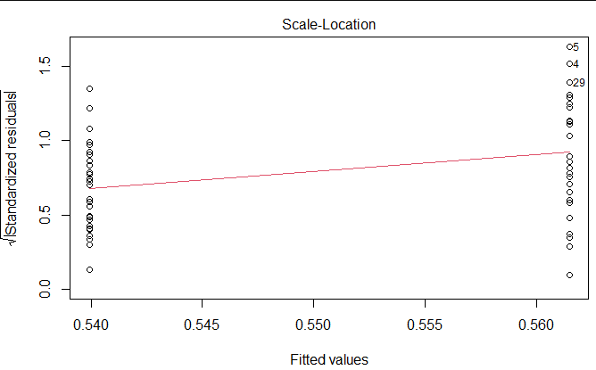

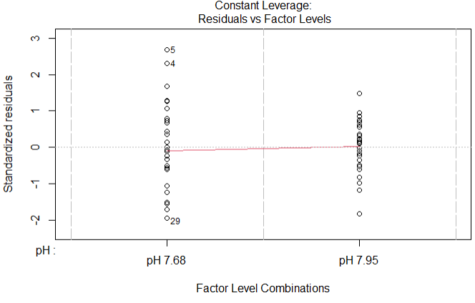

**Fitted linear model for Fv/Fm by pH and over time**

**Linear model formula**: Fv/Fm= 0.63 + 0.10 (pH at Week 1)

No effect of header tank was detected.

|  |  |  |  |  |  |
| --- | --- | --- | --- | --- | --- |
| **Coefficients** | **Estimate** | **Std. Error** | **t value** | ***p*-value** | **Significance** |
| (Intercept) | 0.63075 | 0.020206 | 31.216 | 2e-16 | *** |
| pH 7.68 | -0.09914 | 0.028515 | -3.477 | 0.001088 | ** |
| Week | 0.00375 | 0.007723 | 0.486 | 0.62947 | *** |
| pH:Week | 0.0240 | 0.010726 | 2.238 | 0.02990 | * |
| Header tank effect | NA | NA | NA | NA | NA |

Significance. Codes: 0 ‘***’ 0.001 ‘**’ 0.01 ‘*’ 0.05 ‘.’ 0.1 ‘ ’ 1

Residual standard error: 0.04241 on 48 degrees of freedom

Multiple R-squared: 0.3476

Adjusted R-squared: 0.3068

F-statistic: 8.524 on 3 and 48 df

*p*-value: 0.000325

**Model ANOVA**

|  |  |  |  |  |  |
| --- | --- | --- | --- | --- | --- |
| **Variation** | **df** | **Sum of squares** | **Mean square** | **F-value** | ***p*-value** |
| pH | 1 | 0.02056 | 0.020561 | 11.433 | 0.00144 |
| Week | 1 | 0.01642 | 0.016421 | 9.131 | 0.00402 |
| pH:Week | 1 | 0.00901 | 0.009007 | 5.009 | 0.0299 |
| Residuals | 48 | 0.08632 | 0.001798 |  |  |

**Shapiro-Wilk normality test**

|  |  |  |
| --- | --- | --- |
| **Data** | **W** | ***p*-value** |
| Fv/Fm | 0.89214 | 0.02 |

**Tukey’s HSD test comparing Fv/Fm by pH** **at Week (Wk) 1, 2, 3 and 4**

|  |  |  |  |  |  |
| --- | --- | --- | --- | --- | --- |
| **Comparison** | **Difference** | **Lower** | **Upper** | ***p*-value** | **Significance** |
| pH 7.95:Wk 1 - pH 7.68:Wk 1 | **0.097571** | 0.036373 | 0.15877 | 0.000192 | *** |
| pH 7.68:Wk 2 - pH 7.68:Wk 1 | 0.115214 | 0.051517 | 0.178911 | 2.03e-05 | *** |
| pH 7.95:Wk 2 - pH 7.68:Wk 1 | 0.122429 | 0.06123 | 0.183627 | 2.6e-06 | *** |
| pH 7.68:Wk 3 - pH 7.68:Wk 1 | 0.083143 | 0.021945 | 0.144341 | 0.002056 | *** |
| pH 7.95:Wk 3 - pH 7.68:Wk 1 | 0.114714 | 0.053516 | 0.175912 | 1.01e-05 | *** |
| pH 7.68:Wk 4 - pH 7.68:Wk 1 | 0.098214 | 0.034517 | 0.161911 | 0.00033 | *** |
| pH 7.95:Wk 4 - pH 7.68:Wk 1 | 0.110714 | 0.043675 | 0.177753 | 0.000106 | *** |
| pH 7.68:Wk 2 - pH 7.95:Wk 1 | 0.017643 | -0.04605 | 0.08134 | 0.986312 |  |
| pH 7.95:Wk 2 - pH 7.95:Wk 1 | 0.024857 | -0.03634 | 0.086055 | 0.896951 |  |
| pH 7.68:Wk 3 - pH 7.95:Wk 1 | -0.01443 | -0.07563 | 0.04677 | 0.994758 |  |
| pH 7.95:Wk 3 - pH 7.95:Wk 1 | 0.017143 | -0.04406 | 0.078341 | 0.98539 |  |
| pH 7.68:Wk 4 - pH 7.95:Wk 1 | 0.000643 | -0.06305 | 0.06434 | 1 |  |
| pH 7.95:Wk 4 - pH 7.95:Wk 1 | 0.013143 | -0.0539 | 0.080182 | 0.998344 |  |
| pH 7.95:Wk 2 - pH 7.68:Wk 2 | 0.007214 | -0.05648 | 0.070911 | 0.999956 |  |
| pH 7.68:Wk 3 - pH 7.68:Wk 2 | -0.03207 | -0.09577 | 0.031626 | 0.746734 |  |
| pH 7.95:Wk 3 - pH 7.68:Wk 2 | -0.0005 | -0.0642 | 0.063197 | 1 |  |
| pH 7.68:Wk 4 - pH 7.68:Wk 2 | -0.017 | -0.0831 | 0.049102 | 0.991146 |  |
| pH 7.95:Wk 4 - pH 7.68:Wk 2 | -0.0045 | -0.07383 | 0.064828 | 0.999999 |  |
| pH 7.68:Wk 3 - pH 7.95:Wk 2 | -0.03929 | -0.10048 | 0.021912 | 0.466786 |  |
| pH 7.95:Wk 3 - pH 7.95:Wk 2 | -0.00771 | -0.06891 | 0.053484 | 0.999909 |  |
| pH 7.68:Wk 4 - pH 7.95:Wk 2 | -0.02421 | -0.08791 | 0.039483 | 0.924853 |  |
| pH 7.95:Wk 4 - pH 7.95:Wk 2 | -0.01171 | -0.07875 | 0.055325 | 0.99921 |  |
| pH 7.95:Wk 3 - pH 7.68:Wk 3 | 0.031571 | -0.02963 | 0.09277 | 0.723342 |  |
| pH 7.68:Wk 4 - pH 7.68:Wk 3 | 0.015071 | -0.04863 | 0.078768 | 0.994643 |  |
| pH 7.95:Wk 4 - pH 7.68:Wk 3 | 0.027571 | -0.03947 | 0.094611 | 0.890841 |  |
| pH 7.68:Wk 4 - pH 7.95:Wk 3 | -0.0165 | -0.0802 | 0.047197 | 0.990759 |  |
| pH 7.95:Wk 4 - pH 7.95:Wk 3 | -0.004 | -0.07104 | 0.063039 | 1 |  |
| pH 7.95:Wk 4 - pH 7.68:Wk 4 | 0.0125 | -0.05683 | 0.081828 | 0.999032 |  |

**Model plots**

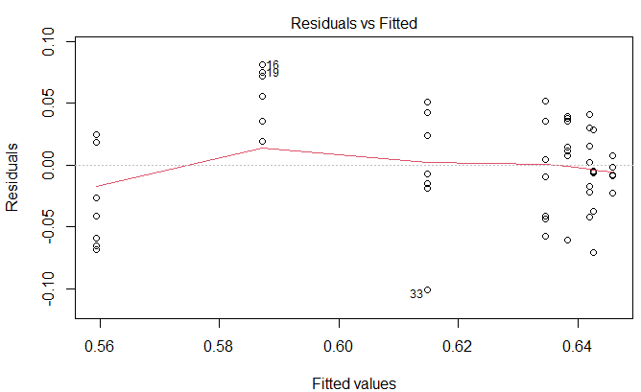

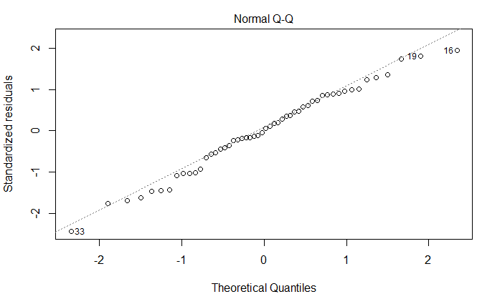

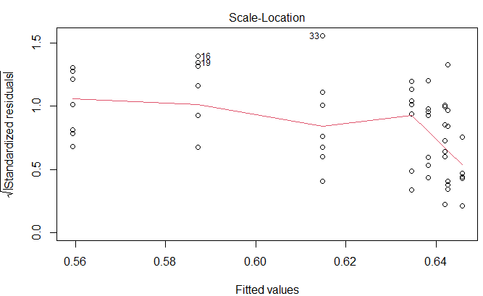

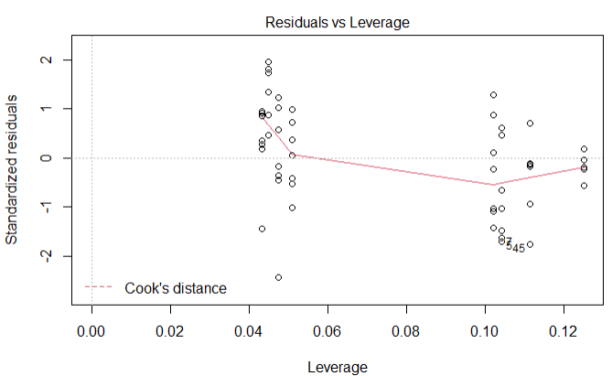

**Fitted linear model for symbiont cell-specific chlorophyll *a* content *per* (pg) by pH**

**Linear model formula**: Chlorophyll *a* = 1.41 - 0.002 (pH 7.68)

No effect of header tank was detected.

|  |  |  |  |  |  |
| --- | --- | --- | --- | --- | --- |
| **Coefficients** | **Estimate** | **Std. Error** | **t value** | ***p*-value** | **Significance** |
| (Intercept) | 1.408118 | 0.061518 | 22.889 | 2e-16 | *** |
| pH 7.68 | -0.001882 | 0.087 | -0.022 | 0.983 |  |
| Header tank effect | NA | NA | NA | NA | NA |

Significance. Codes: 0 ‘***’ 0.001 ‘**’ 0.01 ‘*’ 0.05 ‘.’ 0.1 ‘ ’ 1

Residual standard error: 0.2536 on 32 degrees of freedom

Multiple R-squared: 1.463e-05

Adjusted R-squared: -0.03123

F-statistic: 0.0004681 on 1 and 32 df

*p*-value: 0.9829

**Model ANOVA**

|  |  |  |  |  |  |
| --- | --- | --- | --- | --- | --- |
| **Variation** | **df** | **Sum of squares** | **Mean square** | **F-value** | ***p*-value** |
| pH | 1 | 0 | 0.00003 | 0 | 0.983 |
| Residuals | 32 | 2.059 | 0.06434 |  |  |

**Shapiro-Wilk normality test**

|  |  |  |
| --- | --- | --- |
| **Data** | **W** | ***p*-value** |
| Chlorophyll *a* | 0.96015 | 0.2455 |

**Model plots**

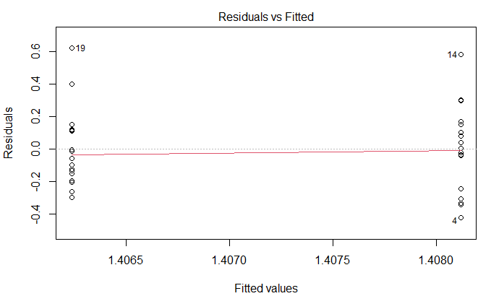

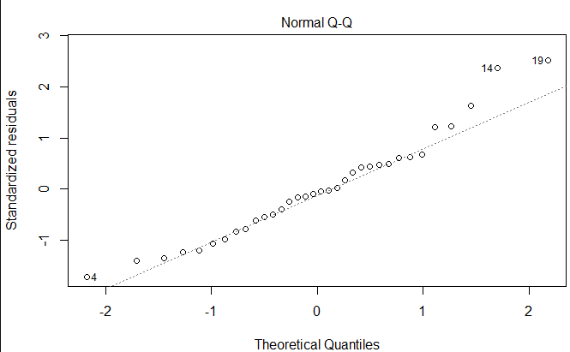

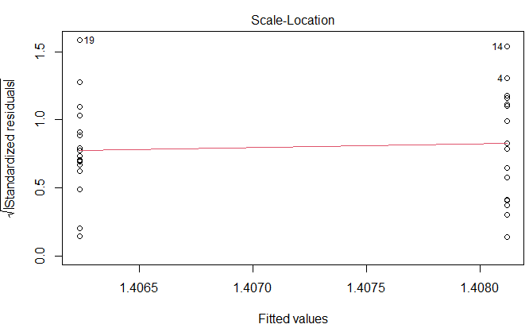

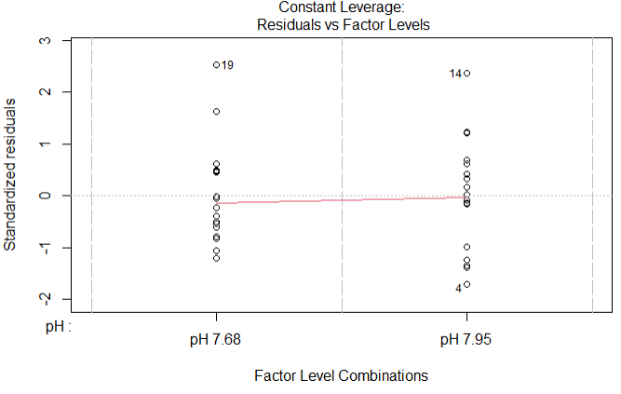

**Fitted linear model for symbiont cell-specific chlorophyll *a* content *per* (pg) over time**

**Linear model formula**: Chlorophyll *a* = 1.51 - 0.05 (time)

No effect of header tank was detected.

|  |  |  |  |  |  |
| --- | --- | --- | --- | --- | --- |
| **Coefficients** | **Estimate** | **Std. Error** | **t value** | ***p*-value** | **Significance** |
| (Intercept) | 1.50747 | 0.11429 | 13.19 | 1.74e-14 | *** |
| Time point | -0.04942 | 0.0522 | -0.947 | 0.351 |  |
| Header tank effect | NA | NA | NA | NA | NA |

Significance. Codes: 0 ‘***’ 0.001 ‘**’ 0.01 ‘*’ 0.05 ‘.’ 0.1 ‘ ’ 1

Residual standard error: 0.2502 on 32 degrees of freedom

Multiple R-squared: 0.02725

Adjusted R-squared: -0.00315

F-statistic: 0.8964 on 1 and 32 df

*p*-value: 0.3509

**Model ANOVA**

|  |  |  |  |  |  |
| --- | --- | --- | --- | --- | --- |
| **Variation** | **df** | **Sum of squares** | **Mean square** | **F-value** | ***p*-value** |
| Time point | 1 | 0 | 0.00003 | 0 | 0.983 |
| Residuals | 32 | 2.059 | 0.06434 |  |  |

**Shapiro-Wilk normality test**

|  |  |  |
| --- | --- | --- |
| **Data** | **W** | ***p*-value** |
| Chlorophyll *a* | 0.96015 | 0.2455 |

**Model plots**

